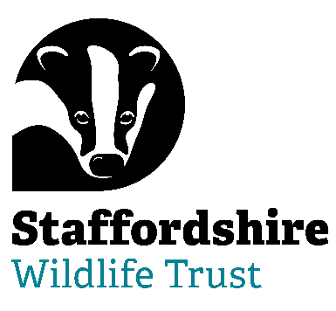**Staffordshire Wildlife Trust is seeking :**

**Main Board Trustees**

**Honorary Secretary**

**Honorary Treasurer**

**Trading Board Trustee**

**Are you able to bring your skills and experience to help with Nature’s Recovery? Staffordshire Wildlife Trust, the leading local charity in Staffordshire, is dedicated to the conservation of nature and connecting people with their local wildlife**

Trustee Tenure: 4 year term – maximum 3 terms

Regularity: 9 meetings a year + additional opportunities

Location: The Wolseley Centre, Wolseley Bridge, Stafford, ST17 0WT

***Help us to protect and enhance the wildlife and wild places of Staffordshire and promote understanding, enjoyment and involvement in the natural world.***

We are looking for Trustees to join our Board at an exciting time of growth and ambition. Join us on our journey to reach 30% of land managed for wildlife by 2030 and 1 in 4 people taking action for wildlife in Staffordshire. In addition, we are also looking for someone to join our Trading Board.

No previous experience of acting as a Trustee is necessary. We are especially looking for applicants with experience or knowledge in the following areas:

* Finance and business accounting with professional qualifications (will form a succession plan to be the next Honorary Treasurer)
* Legal experience and qualifications (will form a succession plan for the next Hon Secretary)
* Environment protection and climate mitigation
* Nature Conservation with experience and professional qualifications in Ecology
* Commercial Business in Retail

The role of our Trustees is varied and stimulating. You will be bringing your expertise, experience and passions to help lead a dynamic, multi-functional, multi-specialist organisation.

**About Us**

“Staffordshire Wildlife Trust protects and enhances the wildlife and wild places of Staffordshire and promotes understanding, enjoyment and involvement in the natural world.”

A registered charity established in 1969 it is one of 46 county Wildlife Trusts throughout the UK and is supported by over 19,000 members.

The Trust owns or manages 45 nature reserves covering an area of over 1947 hectares. Our 130 staff are based in six locations around the county including our Headquarters at Wolseley Bridge, Stafford, with our work divided up into five departments: Conservation Delivery, Engagement, Marketing & Activism, Fundraising, Membership & Resources, HR & Support Services and Commercial. The Trust has a diverse workforce including site wardens, wildlife surveyors, community and education officers, catering, retail and administration.

In addition, we have a trading company which looks after the trading side of our business. This includes a café at The Wolseley Centre, charity shops in Leek, Penkridge and Codsall and a retail shop in the Wolseley Centre.

We are welcoming. One of the core values of Staffordshire Wildlife Trust is that we nurture a culture of equality, inclusivity and diversity.

We are welcoming to those underrepresented in our communities and we strive to listen, learn and share from each other.

Staffordshire Wildlife Trust is committed to keeping children and young people safe, you can see our policy here:  <https://www.staffs-wildlife.org.uk/our-policies>

Safeguarding and protecting our visitors, customers, members, staff and volunteers is the responsibility of every trustee, employee, and volunteer at Staffordshire Wildlife Trust.

For more information and to request an application pack contact Staffordshire Wildlife Trust on [jobs@staffs-wildlife.org.uk](mailto:jobs@staffs-wildlife.org.uk) or visit our website [www.staffs-wildlife.org.uk/jobs](http://www.staffs-wildlife.org.uk/jobs)

**Closing Date**: **Friday 11th April 2025**

**Interviews:  Week commencing Monday 28th April 2025**