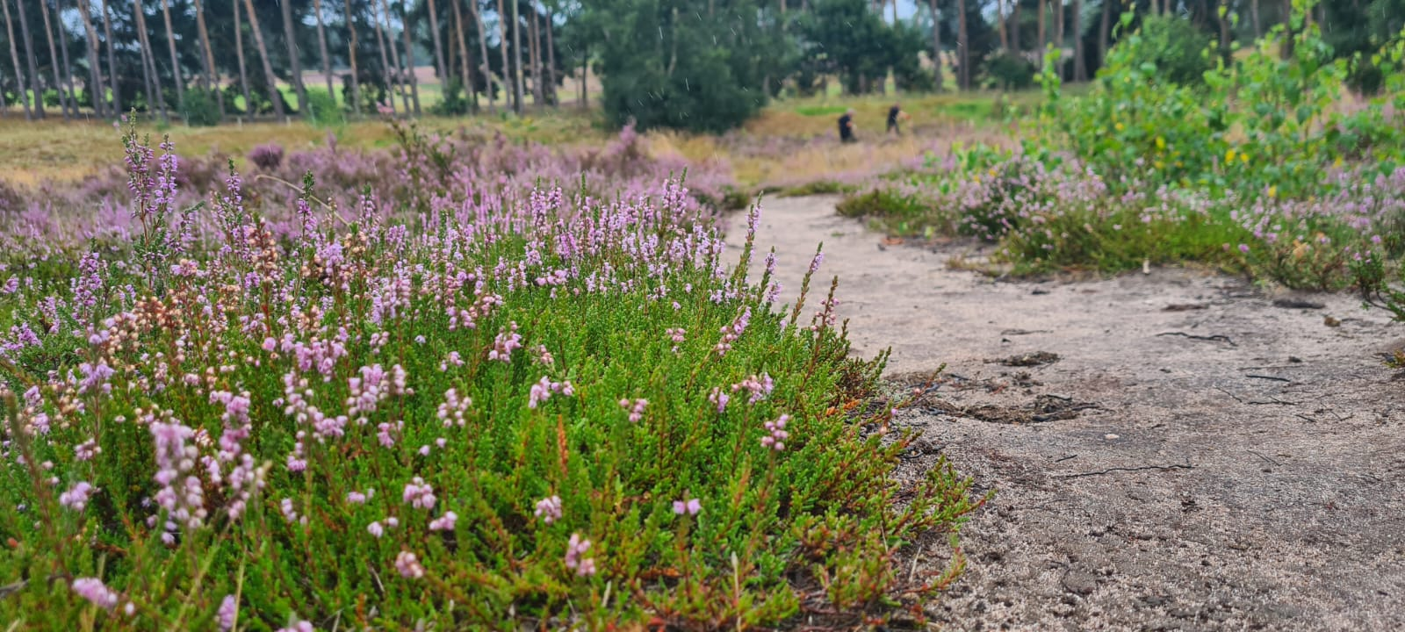

© Kevin Palmer

**Highgate Common and Southern Heathlands Reserves Assistant**

**Be part of a Wilder Future**

***Closing date:* Friday 8th November 2024 at 9am**

***Interview date:* week commencing Monday 18th November 2024**

Please submit your completed application to jobs@staffs-wildlife.org.uk before the closing date.

**Join Our Movement**

We are the county’s leading conservation charity, committed to protecting wildlife and inspiring a lifelong love of nature. Our climate is in crisis and nature needs our help, but together we can make a difference.

**Our 50-year vision is for a thriving county with wildlife at its heart, which everyone enjoys, values and wants to play their part in protecting and improving.**

**Our mission is to ensure that:**

We protect and enhance the wildlife and wild places of Staffordshire and promote understanding, enjoyment and involvement in the natural world.

Working for Staffordshire Wildlife Trust, in any role, means you are part of our ambition to halt and reverse nature’s decline in Staffordshire and across the UK, and to get more people to take meaningful action for wildlife. Whether you work in IT, in our cafes, or out on our nature reserves you will be working with colleagues towards the common purpose of a county richer in wildlife.

CHRISTINE HARDING SWT

**Working for Us**

Your journey in the Trust starts with your induction. Whatever role you're here to do, we'll explain what to expect, show you where to go, and make sure you understand your new environment before you get going.

You’ll get chance to see what others in your teams, and across the Trust are doing through job shadowing and team working. We have 45 other Wildlife Trusts, working passionately just like us, whose knowledge and experience you can also draw from.

**Learning and Development** - one size doesn’t fit all, we will work with you to identify where you and the organisation want to grow and develop, and put together a personal plan that works for you, whether that’s on-the-job training, flexible e-learning, or one-to-one support.

If we need you to hold a qualification for your role, from either a legal or professional point of view, we’ll cover the cost of your membership fee where needed as part of your continuous professional development.

We believe work-life balance is important. We work 35 hours a week, and we believe a good work life balance makes for happier, healthier employees. We support flexible working wherever possible and we are currently trialling a hybrid working model.

**We have a range of benefits that support you when working for us:**

* *10% Non-contributory Pension*
* *Employee Assistance Programmes*
* *Life Assurance (4 x salary)*
* *Salary Sacrifice schemes for cycle to work and Electric vehicles*
* *25 Days basic holiday allowance (rising to 30 days after 10 years’ service), plus bank holidays, and extra Christmas leave (pro rata).*
* *15% discount in our cafes*
* *PPE and uniform provided as required.*

**What We Stand For**

We are:

**Resourceful:** Making best use of what we have, and always alive to opportunities to do things better and more efficiently

**Passionate:** Making the case for valuing and protecting wildlife

**Pioneering:** Using new and innovative ways to achieve our vision helping us led by example

**Evidence** **Based:** Making our case on scientific facts

**Welcoming:** Giving our members, our supporters, and the wider public the best service possible

**Professional:** Striving to be the best we can be in all that we do, seeking continuous improvement and benchmarking our performance

**Collaborative:** Working in partnerships between staff, volunteers, members, communities, landowners, businesses and many others to achieve our vision

**The Basics**

**Job Title: Highgate Common and Southern Heathlands Reserves Assistant**

**Contract Type:** Permanent.

**Hours:** 35 hours per week. Flexible working requests will be considered.

**Pay £20,820 per annum dependent on skills & experience.**

**Work Location:** Based at Highgate Common in South Staffordshire at the Cory Community Centre but with regular travel across Staffordshire with a fleet vehicle

**Responsible to:** You will report to the Southern Heathlands Reserves Manager.

**Who We’re Looking For**

Looking for the chance to work on some of the important heathland sites in the West Midlands?

This is an exciting opportunity for someone furthering their career in conservation land management to work for Staffordshire’s leading wildlife conservation organisation.

The successful candidate will have some experience in the practical management and restoration of land for conservation, working with volunteers and the day-to-day running of nature reserves.

Based at our lowland heathland site in south Staffordshire, Highgate Common and working across our other southern heathland reserves, the role will enable the post holder to work alongside the Reserves Manager, colleagues in the Conservation Department & volunteers to ensure the management and continuous improvement of a suite of important nature reserves across Staffordshire.

With your endless passion for our work, you’ll help with the protection and care of habitats, wildlife, property and machinery, and your passion will inspire others to love the beautiful places as much as you do. We want you to engage with visitors, making time to talk to them, not rushing away to the next task.

This will see you responding to queries and explaining the value of the work being undertaken. After all, your passion and dedication could fire the imagination that makes a visitor become a member for the rest of their life.

**Key Responsibilities**

1. Working alongside the Southern Heathlands Reserves Manager, carry out practical management work on our Nature Reserves. Carry out high-quality habitat conservation work individually but also within a small team.
2. Lead volunteer tasks - leading and working with the volunteers on regular work party days which will involve tools talks on task days, recruitment, volunteer inductions, and also working with corporate groups regularly.
3. Carry out land management activities on reserves where required, such as bracken control, scrub clearing, bare earth creation, emptying dog bins on a weekly basis, litter picking, and fencing repairs. Work adhering to reserve management plans and grant schemes. Assist with ongoing restoration projects.
4. Assist in carrying out safety checks on Highgate Common, the Cory Community Centre and vehicles and machinery owned by the Trust.
5. Carry out general maintenance tasks at the Cory Community Centre.
6. Under the guidance of the heathland manager, maintain tools and machinery to ensure equipment is kept in an optimum condition and adhering to health and safety legislation which will involve regular checks and keeping records and log sheets. Assist in maintaining the workshop in a safe and tidy condition.
7. Ensure that all work is undertaken to comply with Health and Safety guidelines as required by Trust policies and legislation. This will involve assisting the Reserve Officers in maintaining up-to-date records and site safety audits on reserves.
8. Working as part of the team to provide cover and support for colleagues in the wider Conservation department on various projects
9. Represent the Wildlife Trust and its aims when working with individuals, groups and organisations, and raise awareness of the work of Staffordshire Wildlife Trust and be an ambassador for the Charity.
10. Regularly interact with visitors to the reserves to promote the work of the trust and promote membership where appropriate.
11. All staff should recognise the contribution that membership makes towards the running of the organisation. The postholder is therefore expected to understand the need for high standards of service to existing members and recognise their role in contributing towards ongoing membership recruitment.
12. In order for the organisation to work effectively you may be required to assist with other areas of work and therefore you should be prepared to undertake other duties, appropriate to the post, as delegated by your line manager.
13. All staff are required to abide by organisational policies and procedures.

**What we’re looking for**

|  |  |
| --- | --- |
| **Personal Qualities** | |
| **Passionate and Energetic** | You will believe in our core purpose, and be passionate about tackling the nature and climate crises and have an understanding of the part we play. |
| **Team focused and supportive** | You will be working as part of a small team and also with the wider reserves department and project officers. |
| **Flexibility** | This role will require some evening and weekend working, as well as occasional unusual hours. |
| **Professionalism** | You will be a good advocate and represent the trust at all times in a professional manner both with members of the public on site and professional partners. |
| **Determination and Resilience** | You will take pride in delivering high quality work while working in challenging conditions and in all weathers. |
| **Problem Solving** | Often working in remote areas, you will be methodical in your approach to planning work and solving problems. |

E = Essential D= Desirable

|  |  |  |
| --- | --- | --- |
| **Qualifications** | **E** | **D** |
| A degree or equivalent relevant experience in an environmental discipline | X |  |
| CS 30/31 Chainsaw Operator |  | X |
| Use of Brush cutter/clearing saw |  | X |
| Emergency First Aid outdoors |  | X |
| PA1/PA6 |  | X |
| Use of ATV |  | X |
| Driving licence categories B, and E (E not essential but would be beneficial). | X |  |
| Off road driving |  | X |
| **Experience** |  |  |
| Evident experience of leading and managing volunteers | X |  |
| Experience of delivering practical habitat management works across different habitats, specifically heathland, and acidic grassland habitats but also including scrub, bare earth, mire, wet heath and woodland. | X |  |
| Proven communication skills, written and verbal | X |  |
| Experience in monitoring species and habitats. |  | X |
| Experienced in a wide range of practical estate work including fencing, footpath maintenance and construction tasks | X |  |
| Experience in delivering guided walks and talks |  | X |
| **Skills & Knowledge** |  |  |
| A broad knowledge and interest in natural history | X |  |
| Organising and leading practical work parties | X |  |
| Use and maintenance of power tools (chainsaws/brush cutters etc), hand tools |  | X |
| Knowledge of Health and Safety legislation and its application | X |  |
| Knowledge of invertebrates and the heathland habitat |  | X |
| **Ability** |  |  |
| The job involves regular driving between reserves and occasionally further afield for which pool vehicles are available. You will have access to fleet vehicles but you must hold a full driving licence and possess your own vehicle. | X |  |
| The post will require various working patterns which include occasional early starts, evening finishes and sometimes weekend working. | X |  |
| The job involves manual handling | X |  |
| You must be able to demonstrate the ability to organise your own workload and work unsupervised and as part of a small team. | X |  |
| You must be a competent user of IT packages including MS Office, the use of GIS mapping software and design software. |  | X |
| The post requires strong commutation skills with a variety of people including project staff, partner organisations, farmers, land managers and land owners. | X |  |
| The job involves working outside in all weather conditions and seasons. | X |  |